FAQ
- How can we submit our transcripts to Erasmus Office?
A: Because of online education, our office will take your transcripts from student affairs. You do not have to submit them.

- If I took last year’s exam and if I am eligible for Erasmus, do I have to fill application form and take the exam this year?
- No. You do not have to fill the form and take the exam if you were eligible last year.

- I cannot see any university agreement for my department. Does it mean that I cannot go for Erasmus Mobility?
- No, you may apply. Even if your department does not have any agreement for study mobility, they may have agreements next semester. Or you may apply for internship mobilities. For internship mobility, we do not need agreements with companies.

- Will the Erasmus language exam be online? When?
- The exam will be online. We will announce the date and time.

- If we are selected as eligible, will the mobility be online or physical?
- It is not clear now. After you are nominated, you will send your applications to our partner universities or get acceptances from companies. If they and their country approve physical mobilities, you may go for physical mobilities.

- Does Erasmus grant cover insurance, visa and travel fees?
- No. Erasmus gives monthly grant. We calculate your grant depending on your mobility durations. You will get 80% of your money before the mobility and get 20% of it after mobility. Internship mobility should be at least 2 months and study mobility should be at least 3 months.
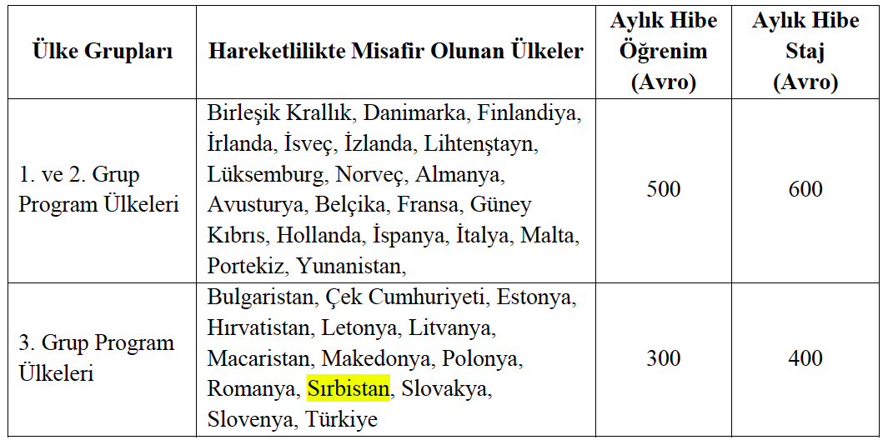

- What is the difference between Erasmus and Exchange?
- Erasmus mobility is funded by European Union and offers both study and internship mobilities. But Exchange mobility offers only study mobility and it is not funded. You may go to Non-Erasmus countries by using exchange mobility. You may see http://exchange.agu.edu.tr/ website.

- I filled the form two or three times, does it cause a problem?
- No problem. We will only keep the last one.

- Can we get grant for online mobility?
A. If you stay in Turkey and do online mobility, you may not get grant.

- If I start physical mobility, may I continue as online because of COVID situation?
- You may start as physical and continue as online or vice versa.

